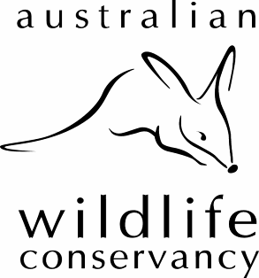
4360 (Lot 201) Lilydale Rd
Chidlow, 6556
Ph: 9572 3169
Fax: 9572 3107
ABN: 36 068 572 556
Email: sanctuaries@australianwildlife.org
Web: www.australianwildlife.org

South-west Region Volunteer Newsletter April 2008

Greetings to our great team of volunteers and thankyou for all the great work in 2007. We thought you might be interested in a few highlights from the South-west team.

Australian Wildlife Conservancy
AWC has been busy in 2007 and early 2008 acquiring our 16-18th properties Kalamurina (near Lake Ayre), Piccaninny Plains (Cape York) and Pungalina (Gulf Country). We now own 2.1 million hectares (5.3 million acres).

In other news, our head office has relocated to Subiaco as they have outgrown the premises at West Perth.

We welcome our new South-west Regional Manager Arvid Hogstrom who commenced in December. We hope to soon employ a new Regional Ecologist and another Sanctuary Officer.
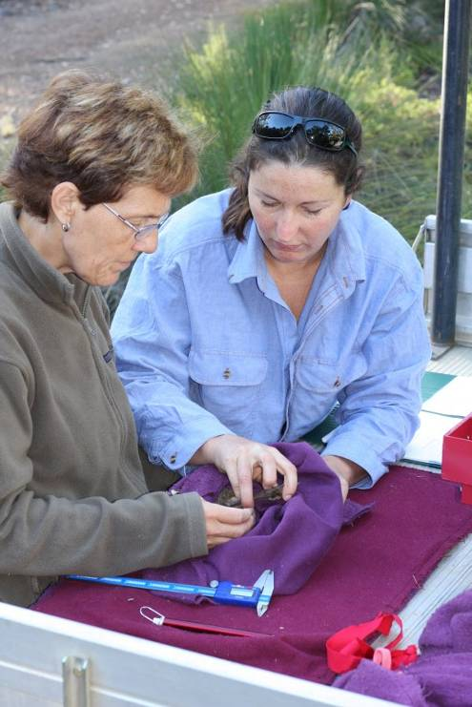

Karakamia News
At Karakamia we have been very busy with the research into the massive Woylie decline that has been seen in the south-west. You may have seen recently in the news that the Woylie has been relisted on the Threatened Species list as Endangered. The population at Karakamia has not observed any decline and has become a very significant population of Woylies. Plans are currently underway to translocate woylies to a new fenced area of Paruna and possibly Scotia if the rainfall is suitable in 2008.

We had over 2500 visitors to Karakamia last year especially during Spring, our highest number which has been keeping Trish & Alison busy. The Woylies, Tammar Wallabies, Quenda not to mention the Brushtail possums are as captivating as ever.

Paruna News
Photo: Jo Williams & Jane Brown process a woylie as part of the decline project. Photographer: Tony Brown.
The walk trails are due to open mid April after our trail work day on the 12th. Please keep promoting the trails as they need to be used. If you would like some Paruna brochures, please let Trish know and I can post some out to you.

Steve and his family have settled into the house at Paruna and have been busy with feral animal control and monitoring. He and Mark have had some success targeting feral pigs in recent weeks! We have acquired another block at Paruna which is going to be completely fenced in the next month or so to create a feral free block like Karakamia. Jo is busy setting up pit traps and quadrats so we can survey the block before and after the fence goes up. Steve and Mark can then get busy removing any feral animals from the block especially foxes and cats so that we can translocate woylies into the area.
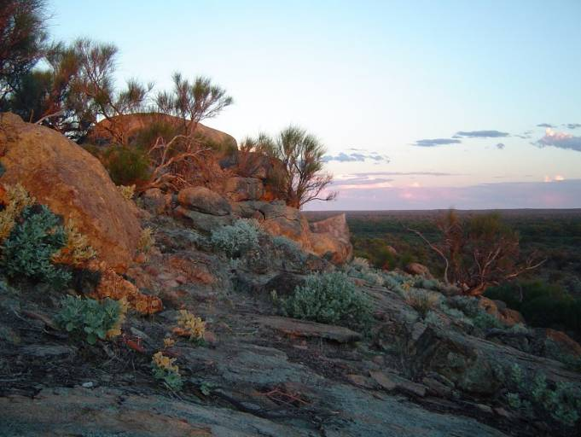

Mt Gibson
Craig, Stan & Mary have all been busy with the replacement of the old homestead and building the new residence for the manager. The Water Corporation has also donated some old dongas some of which have been converted into a volunteer centre so we now have beds, showers and toilets available for volunteers and visiting researchers. The campsite is currently being relocated and upgraded so camping is temporarily unavailable. They had some good summer rainfall so hopefully if the season continues we might be in for a good wildflower season! If you are keen to camp at Mt Gibson later this year you can book with Stan & Mary at the homestead on their new number 9963 6034. The CRC project is continuing and several new species of small mammal have been trapped at Mt Gibson including a Spinifex Hopping Mouse and a Southern Ningaui.
Photo: Beanthiny Rocks by Sally Bart

Faure Island
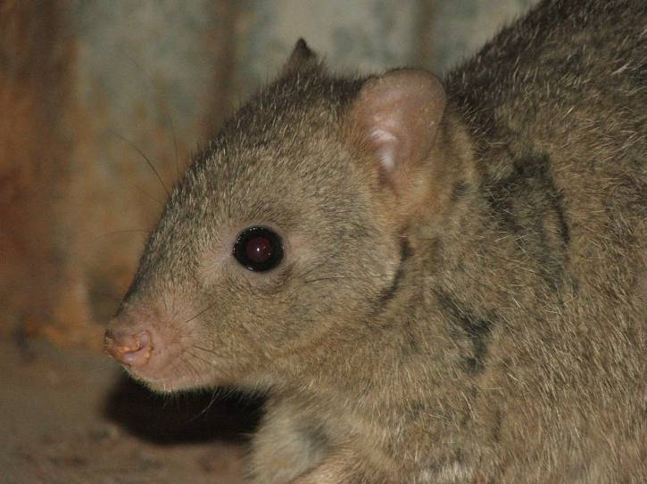
Some great trapping results coming from Faure in 2007 with record numbers of Boodies and increasing numbers of Western Barred Bandicoots despite the very low rainfall in 2007. (Only 75mm fell the entire year.) A total of 778 Boodies, 143 Shark Bay Mice, 66 Western Barred Bandicoots and 38 Banded Hare Wallabies were trapped during 2007. We are still having challenges trapping Banded Hare Wallabies with the Boodies getting into the traps but the animals that are trapped are in good condition and breeding. We are encountering the same problem with the very shy Stick-nest Rats but Jo has seen prints in several locations over the island. The 5th translocation of Banded Hare Wallabies is planned for 2008 and we have already had a good fall of 68mm rain in February & 133mm in March.
Photo: Boodie by Amy Griffiths

Volunteer Activities for 2008
Date | Activity | Sanctuary | Time
Saturday 12th April | Trail Work | Paruna | 9am-2ish (booked out)
Saturday 31st May-Monday 2nd June | Various | Mt Gibson | TBA
June 15th June | Planting | Paruna | 9-1
Saturday 26th July | Planting | Karakamia | 12-4 + walk (4.45pm)
Could you please phone or email the Karakamia Office to give us an idea of numbers for all volunteer activities on (08) 9572 3169 or trish@australianwildlife.org

What to Bring:
- Gardening Gloves
- Gumboots for Karakamia & Paruna planting day
- Hat & Suncreen or Raincoat depending on weather
- Water
- Trowels (planting days)
- Lots of enthusiasm!

For the trail work day at Paruna, you will need a reasonable level of fitness and it is not suitable for young children. We will have a maximum of 20 participants.

At Karakamia we are continuing revegetating areas around the dam using plants from our nursery & a local nursery. At Paruna we will also be planting around the dams at Avon Rd and the Nissen Hut for the morning. Both planting day are suitable for all ages and will be followed by a sausage sizzle. At Karakamia a free spotlight walk after planting will be available.

For the weekend at Mt Gibson, there is a maximum of 15 people and need to be of reasonable fitness. Facilities are basic. There are a number of beds or you can camp-out if you wish. It is likely to be very cold at night. We will be car-pooling, so let me know if you need a lift or can provide one. The main projects for the weekend are to maintain the Homestead Ridge Walk Track, campsite maintenance, pit trap maintenance, painting, weed control and other activities to be advised. Contact Trish for bookings and further information.

Thursday Team
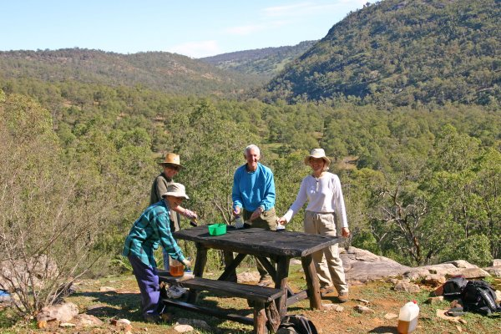
At Karakamia and Paruna we have formed a small team of regular volunteers on Thursdays that assist with tasks such as the nursery, herbarium, weed control, trail work, linseeding, fauna & flora surveys and numerous other tasks depending on skills and interests. If you are interested in assisting on a regular basis on Thursdays please contact Trish (but we can only take a small number of volunteers at any one time.)
Thursday team - linseeding furniture at Paruna. Photo: Tony Brown

In the Subiaco office, Beth occasionally requires assistance with mailouts and other duties (weekdays). If you are able to assist her please email her on beth@australianwildlife.org or 9380 9633.

Our preferred method of contact is email as it saves considerably on printing, paper and postage, not to mention less envelopes to stuff! You will also receive more regular updates and advance notice on volunteer dates and the latest edition of AWC’s newsletter “Wildlife Matters” which is hosted on our website www.australianwildlife.org If you don’t want to continue to be on the volunteer mailing list or have changed address could you notify us. Please email your address to trish@australianwildlife.org. (Those of you using hotmail accounts may need to keep me updated of your address as I frequently receive bounce messages from inactive accounts). Could you clearly state your full name and address in the email so that we can find you in our volunteer database.

Thank you for your continued support of AWC!

South-west Regional Team

Arvid Hogstrom, Jo Williams, Trish Gardner, Steve Edwards, Craig Stephens, Stan & Mary Ennor, Mark Thiele & Alison Kuiper.

